# Module 2 - Assignment 2

## Roberts, Damon

### Multiple Linear Regression and Special Issues

### Initialize RStudio

options(tidyverse.quiet = TRUE)  
  
library(tidyverse)  
library(GGally)

##   
## Attaching package: 'GGally'

## The following object is masked from 'package:dplyr':  
##   
## nasa

library(MASS)

##   
## Attaching package: 'MASS'

## The following object is masked from 'package:dplyr':  
##   
## select

library(leaps)

### Task 1 - Import data and convert variables

bike = read_csv("hour.csv")

## Parsed with column specification:  
## cols(  
## instant = col_double(),  
## dteday = col_date(format = ""),  
## season = col_double(),  
## yr = col_double(),  
## mnth = col_double(),  
## hr = col_double(),  
## holiday = col_double(),  
## weekday = col_double(),  
## workingday = col_double(),  
## weathersit = col_double(),  
## temp = col_double(),  
## atemp = col_double(),  
## hum = col_double(),  
## windspeed = col_double(),  
## casual = col_double(),  
## registered = col_double(),  
## count = col_double()  
## )

bike2 = bike %>%  
 mutate(season = as_factor(as.character(season))) %>%  
 mutate(season = fct_recode(season,  
 "Spring" = "1",  
 "Summer" = "2",  
 "Fall" = "3",  
 "Winter" = "4")) %>%  
 mutate(yr = as_factor(yr)) %>%  
 mutate(mnth = as_factor(mnth)) %>%  
 mutate(hr = as_factor(hr)) %>%  
 mutate(holiday = as_factor(as.character(holiday))) %>%  
 mutate(holiday = fct_recode(holiday,  
 "NotHoliday" = "0",  
 "Holiday" = "1")) %>%  
 mutate(workingday = as_factor(as.character(workingday))) %>%  
 mutate(workingday = fct_recode(workingday,  
 "NotWorkingDay" = "0",  
 "WorkingDay" = "1")) %>%  
 mutate(weathersit = as_factor(as.character(weathersit))) %>%  
 mutate(weathersit = fct_recode(weathersit,  
 "NoPrecip" = "1",  
 "Misty" = "2",  
 "LightPrecip" = "3",  
 "HeavyPrecip" = "4")) %>%  
 mutate(weekday = as_factor(as.character(weekday))) %>%  
 mutate(weekday = fct_recode(weekday,  
 "Sunday" = "0",  
 "Monday" = "1",  
 "Tuesday" = "2",  
 "Wednesday" = "3",  
 "Thursday" = "4",  
 "Friday" = "5",  
 "Saturday" = "6"))

Factors are important for plotting and using categorical variables in regression models. While seasons were assigned a numeric value of 1-4 in the dataset, that value has no actual meaning in our calculations. Thus, we needed to convert the numeric values into characters, then create factors from those characters so they can be used in analysis.

### Task 2 - Calculate variable correlations

ggcorr(bike2, label = TRUE)

## Warning in ggcorr(bike2, label = TRUE): data in column(s) 'dteday',  
## 'season', 'yr', 'mnth', 'hr', 'holiday', 'weekday', 'workingday',  
## 'weathersit' are not numeric and were ignored

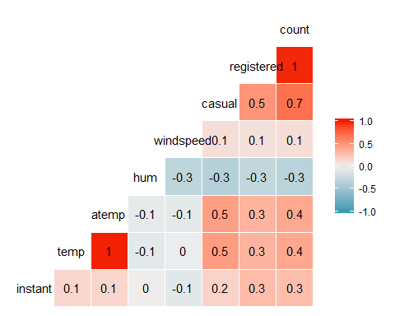

It appears *temp* and *atemp* have the highest correlation with count at approximately 0.4 each.

### Task 3 - Visualize relationship between categorical and response variables

ggplot(bike2, aes(season, count)) + geom_boxplot() + labs(title = "Count by Season")

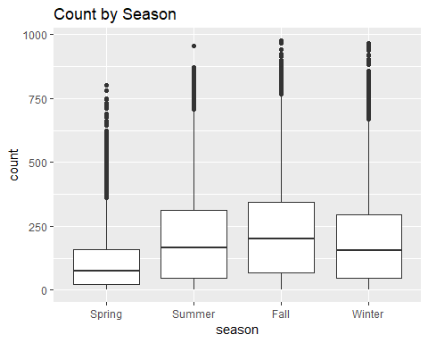

ggplot(bike2, aes(yr, count)) + geom_boxplot() + labs(title = "Count by Year")

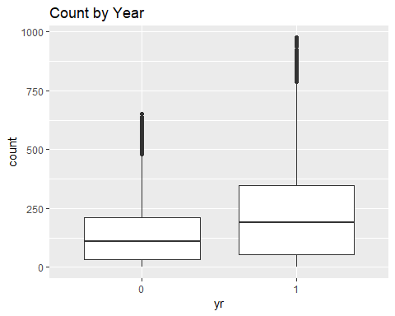

ggplot(bike2, aes(mnth, count)) + geom_boxplot() + labs(title = "Count by Month")

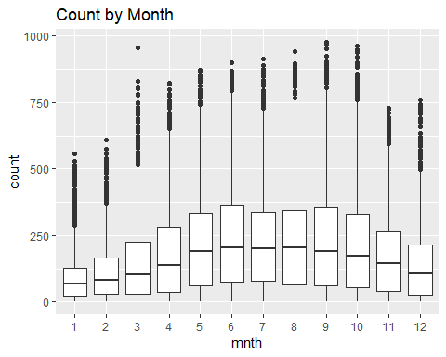

ggplot(bike2, aes(weekday, count)) + geom_boxplot() + labs(title = "Count by Weekday")

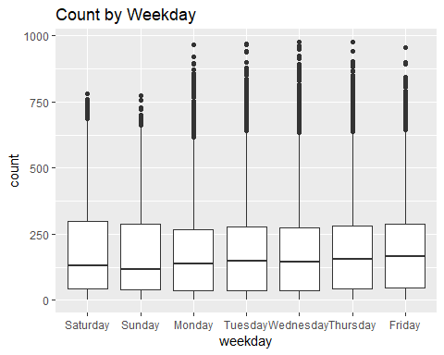

ggplot(bike2, aes(hr, count)) + geom_boxplot() + labs(title = "Count by Hour of Day")

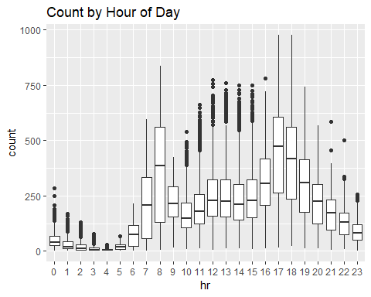

ggplot(bike2, aes(holiday, count)) + geom_boxplot() + labs(title = "Count by Holiday Status")

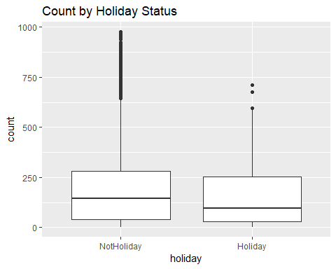

ggplot(bike2, aes(workingday, count)) + geom_boxplot() + labs(title = "Count by Working-Day Status")

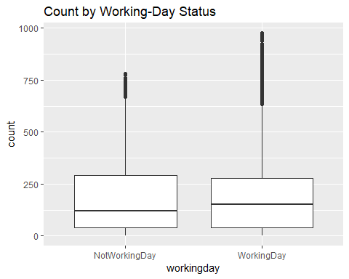

ggplot(bike2, aes(weathersit, count)) + geom_boxplot() + labs(title = "Count by Weather")

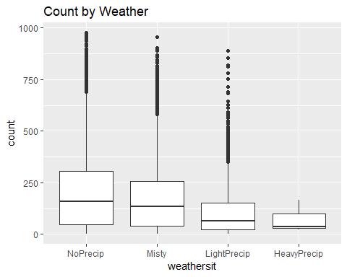

*Season* and *month* both appear to have a good effect on *count*. In *season*, summer and fall tend to have the highest counts, while spring and winter tend to have lower median counts. Similarly, months in the middle of the year (5-9, or May to September) tend to see the highest count, while months at the start and end of each year (Jan-March, and Nov-Dec) have the lowest counts of the year. This suggests counts are dependent on the climate at certain parts of the year, most likely in the Northern Hemisphere where comfortable weather is present during these times. *Weather* also seems to influence *count*, with higher counts when there is little or no precipication recorded. *Year* has only data from 2011 and 2012, so it’s difficult to make conclusions based solely on the year.

*Hour* seems to have the largest effect by causing large variations in count depending on the hour each day. 7-8am and 5-6pm tend to have the highest median count, which corresponds with the typical 8am-5pm work schedule. However, *workingday* does not seem to have a large effect on *count*.This may be due to individuals maintaining their usual biking schedule regardless of whether the day is a holiday, weekday, or weekend. The low influence from *weekday* may be related to this reasoning as well.

*Holiday* appears to have similar median counts whether the day is a holiday or not, although non-holidays tend to have more outliers. This may be due to difference in population size: the dataset includes 16,879 non-holiday obersvations and only 500 holiday observations.

### Task 4 - Building a forward stepwise regression

bike3 = bike2 %>%  
 dplyr::select(-c(instant,dteday,registered,casual))  
  
allmod = lm(count ~ ., bike3)  
  
emptymod = lm(count ~ 1, bike3)  
  
forwardmod = stepAIC(emptymod, direction = "forward", scope=list(upper=allmod,lower=emptymod),  
 trace = TRUE)

## Start: AIC=180764.7  
## count ~ 1  
##   
## Df Sum of Sq RSS AIC  
## + hr 23 286734681 285026910 168713  
## + temp 1 93677759 478083832 177657  
## + atemp 1 91907421 479854170 177721  
## + hum 1 59618351 512143240 178853  
## + mnth 11 42909976 528851615 179431  
## + season 3 37729358 534032233 179584  
## + yr 1 35876722 535884870 179641  
## + weathersit 3 12285030 559476561 180393  
## + windspeed 1 4970060 566791531 180615  
## + holiday 1 546889 571214702 180750  
## + workingday 1 524387 571237204 180751  
## + weekday 6 687929 571073662 180756  
## <none> 571761591 180765  
##   
## Step: AIC=168712.5  
## count ~ hr  
##   
## Df Sum of Sq RSS AIC  
## + atemp 1 50518941 234507969 165324  
## + temp 1 50101685 234925225 165355  
## + mnth 11 44822160 240204750 165761  
## + season 3 39619754 245407156 166117  
## + yr 1 36875130 248151780 166307  
## + weathersit 3 13766672 271260238 167858  
## + hum 1 4924310 280102600 168412  
## + windspeed 1 1476211 283550699 168624  
## + holiday 1 561784 284465126 168680  
## + weekday 6 719530 284307380 168681  
## + workingday 1 485366 284541544 168685  
## <none> 285026910 168713  
##   
## Step: AIC=165324  
## count ~ hr + atemp  
##   
## Df Sum of Sq RSS AIC  
## + yr 1 33463769 201044200 162650  
## + weathersit 3 9227265 225280704 164632  
## + hum 1 7008684 227499285 164799  
## + season 3 6580442 227927527 164835  
## + mnth 11 5854560 228653409 164907  
## + weekday 6 607638 233900331 165291  
## + holiday 1 274006 234233963 165306  
## + temp 1 152153 234355816 165315  
## + windspeed 1 120557 234387412 165317  
## + workingday 1 90170 234417799 165319  
## <none> 234507969 165324  
##   
## Step: AIC=162650.2  
## count ~ hr + atemp + yr  
##   
## Df Sum of Sq RSS AIC  
## + weathersit 3 8408358 192635842 161914  
## + season 3 7190305 193853896 162023  
## + mnth 11 6486062 194558138 162102  
## + hum 1 4341837 196702363 162273  
## + weekday 6 641648 200402552 162607  
## + holiday 1 324763 200719438 162624  
## + windspeed 1 109311 200934889 162643  
## + workingday 1 106404 200937797 162643  
## + temp 1 91735 200952465 162644  
## <none> 201044200 162650  
##   
## Step: AIC=161913.7  
## count ~ hr + atemp + yr + weathersit  
##   
## Df Sum of Sq RSS AIC  
## + season 3 7771024 184864818 161204  
## + mnth 11 7464989 185170852 161249  
## + hum 1 805099 191830743 161843  
## + weekday 6 686172 191949670 161864  
## + holiday 1 413536 192222305 161878  
## + workingday 1 212428 192423414 161897  
## + temp 1 134482 192501360 161904  
## + windspeed 1 44407 192591435 161912  
## <none> 192635842 161914  
##   
## Step: AIC=161204.1  
## count ~ hr + atemp + yr + weathersit + season  
##   
## Df Sum of Sq RSS AIC  
## + mnth 11 2051323 182813495 161032  
## + hum 1 1810161 183054657 161035  
## + weekday 6 704303 184160515 161150  
## + holiday 1 392702 184472116 161169  
## + temp 1 352584 184512234 161173  
## + workingday 1 214973 184649845 161186  
## <none> 184864818 161204  
## + windspeed 1 158 184864660 161206  
##   
## Step: AIC=161032.2  
## count ~ hr + atemp + yr + weathersit + season + mnth  
##   
## Df Sum of Sq RSS AIC  
## + hum 1 2356411 180457084 160809  
## + weekday 6 692672 182120823 160978  
## + holiday 1 312321 182501174 161004  
## + temp 1 233052 182580443 161012  
## + workingday 1 203953 182609542 161015  
## <none> 182813495 161032  
## + windspeed 1 68 182813428 161034  
##   
## Step: AIC=160808.7  
## count ~ hr + atemp + yr + weathersit + season + mnth + hum  
##   
## Df Sum of Sq RSS AIC  
## + weekday 6 581105 179875980 160765  
## + holiday 1 322997 180134087 160780  
## + workingday 1 194139 180262945 160792  
## + windspeed 1 114287 180342797 160800  
## + temp 1 100025 180357059 160801  
## <none> 180457084 160809  
##   
## Step: AIC=160764.7  
## count ~ hr + atemp + yr + weathersit + season + mnth + hum +   
## weekday  
##   
## Df Sum of Sq RSS AIC  
## + holiday 1 274717 179601263 160740  
## + workingday 1 274717 179601263 160740  
## + windspeed 1 112085 179763895 160756  
## + temp 1 77171 179798809 160759  
## <none> 179875980 160765  
##   
## Step: AIC=160740.1  
## count ~ hr + atemp + yr + weathersit + season + mnth + hum +   
## weekday + holiday  
##   
## Df Sum of Sq RSS AIC  
## + windspeed 1 111562 179489701 160731  
## + temp 1 95460 179505803 160733  
## <none> 179601263 160740  
##   
## Step: AIC=160731.3  
## count ~ hr + atemp + yr + weathersit + season + mnth + hum +   
## weekday + holiday + windspeed  
##   
## Df Sum of Sq RSS AIC  
## + temp 1 160954 179328746 160718  
## <none> 179489701 160731  
##   
## Step: AIC=160717.7  
## count ~ hr + atemp + yr + weathersit + season + mnth + hum +   
## weekday + holiday + windspeed + temp  
##   
## Df Sum of Sq RSS AIC  
## <none> 179328746 160718

summary(forwardmod)

##   
## Call:  
## lm(formula = count ~ hr + atemp + yr + weathersit + season +   
## mnth + hum + weekday + holiday + windspeed + temp, data = bike3)  
##   
## Residuals:  
## Min 1Q Median 3Q Max   
## -393.87 -60.66 -7.96 51.31 439.18   
##   
## Coefficients:  
## Estimate Std. Error t value Pr(>|t|)   
## (Intercept) -67.542 6.612 -10.216 < 2e-16 ***  
## hr1 -17.294 5.345 -3.236 0.00122 **   
## hr2 -26.369 5.364 -4.916 8.91e-07 ***  
## hr3 -37.112 5.403 -6.869 6.67e-12 ***  
## hr4 -40.263 5.408 -7.445 1.01e-13 ***  
## hr5 -23.501 5.373 -4.374 1.23e-05 ***  
## hr6 35.393 5.359 6.605 4.10e-11 ***  
## hr7 170.418 5.348 31.864 < 2e-16 ***  
## hr8 310.801 5.342 58.183 < 2e-16 ***  
## hr9 163.101 5.347 30.501 < 2e-16 ***  
## hr10 108.444 5.370 20.196 < 2e-16 ***  
## hr11 133.843 5.409 24.742 < 2e-16 ***  
## hr12 173.142 5.456 31.735 < 2e-16 ***  
## hr13 168.102 5.494 30.600 < 2e-16 ***  
## hr14 152.249 5.525 27.558 < 2e-16 ***  
## hr15 161.707 5.535 29.213 < 2e-16 ***  
## hr16 223.834 5.524 40.522 < 2e-16 ***  
## hr17 377.535 5.491 68.750 < 2e-16 ***  
## hr18 345.587 5.455 63.350 < 2e-16 ***  
## hr19 236.919 5.404 43.841 < 2e-16 ***  
## hr20 157.293 5.375 29.266 < 2e-16 ***  
## hr21 107.840 5.353 20.147 < 2e-16 ***  
## hr22 70.907 5.343 13.272 < 2e-16 ***  
## hr23 32.112 5.338 6.015 1.83e-09 ***  
## atemp 127.975 30.624 4.179 2.94e-05 ***  
## yr1 85.431 1.563 54.658 < 2e-16 ***  
## weathersitMisty -10.409 1.920 -5.421 6.00e-08 ***  
## weathersitLightPrecip -65.189 3.236 -20.145 < 2e-16 ***  
## weathersitHeavyPrecip -62.580 58.893 -1.063 0.28797   
## seasonSummer 38.178 4.856 7.862 4.00e-15 ***  
## seasonFall 32.055 5.749 5.575 2.51e-08 ***  
## seasonWinter 67.994 4.882 13.928 < 2e-16 ***  
## mnth2 3.426 3.920 0.874 0.38219   
## mnth3 14.299 4.407 3.244 0.00118 **   
## mnth4 6.230 6.548 0.951 0.34144   
## mnth5 20.657 7.007 2.948 0.00320 **   
## mnth6 6.238 7.205 0.866 0.38662   
## mnth7 -13.269 8.082 -1.642 0.10065   
## mnth8 7.897 7.879 1.002 0.31622   
## mnth9 32.269 7.001 4.609 4.07e-06 ***  
## mnth10 15.843 6.483 2.444 0.01455 *   
## mnth11 -9.840 6.238 -1.577 0.11474   
## mnth12 -6.256 4.954 -1.263 0.20672   
## hum -82.802 5.554 -14.909 < 2e-16 ***  
## weekdaySunday -16.089 2.878 -5.591 2.30e-08 ***  
## weekdayMonday -6.814 2.970 -2.294 0.02180 *   
## weekdayTuesday -5.240 2.899 -1.807 0.07071 .   
## weekdayWednesday -2.464 2.894 -0.851 0.39469   
## weekdayThursday -2.940 2.892 -1.016 0.30947   
## weekdayFriday 1.356 2.885 0.470 0.63823   
## holidayHoliday -26.228 4.881 -5.374 7.81e-08 ***  
## windspeed -29.167 7.052 -4.136 3.55e-05 ***  
## temp 116.384 29.513 3.943 8.06e-05 ***  
## ---  
## Signif. codes: 0 '***' 0.001 '**' 0.01 '*' 0.05 '.' 0.1 ' ' 1  
##   
## Residual standard error: 101.7 on 17326 degrees of freedom  
## Multiple R-squared: 0.6864, Adjusted R-squared: 0.6854   
## F-statistic: 729.1 on 52 and 17326 DF, p-value: < 2.2e-16

Our final forward model includes *hour*, *atemp*, *year*, *weather situation*, *season*, *month*, *humidity*, *weekday*, *holiday*, *windspeed*, and *temperature*. Overall, this model appears to be good quality for predicting count based on the variables. Aside from the dummy variables, each p-value is below 0.05, indicating they’re significant. The adjusted R-squared value is 0.6854, which is a good value when studying the model. This model also seems to pass the “common-sense” filter; weather attributes will probably have an effect on how many bikers are counted, and we know from looking at the correlations earlier that the hour and time of year are also large influencers.

### Task 5 - Building a backwards stepwise regression

backmod = stepAIC(allmod, direction = "backward", trace = TRUE)

## Start: AIC=160717.7  
## count ~ season + yr + mnth + hr + holiday + weekday + workingday +   
## weathersit + temp + atemp + hum + windspeed  
##   
##   
## Step: AIC=160717.7  
## count ~ season + yr + mnth + hr + holiday + weekday + weathersit +   
## temp + atemp + hum + windspeed  
##   
## Df Sum of Sq RSS AIC  
## <none> 179328746 160718  
## - temp 1 160954 179489701 160731  
## - windspeed 1 177057 179505803 160733  
## - atemp 1 180751 179509498 160733  
## - holiday 1 298893 179627639 160745  
## - weekday 6 498795 179827541 160754  
## - mnth 11 2426171 181754917 160929  
## - hum 1 2300667 181629413 160937  
## - season 3 2398467 181727213 160943  
## - weathersit 3 4208731 183537478 161115  
## - yr 1 30920851 210249597 163480  
## - hr 23 196741474 376070220 173542

summary(backmod)

##   
## Call:  
## lm(formula = count ~ season + yr + mnth + hr + holiday + weekday +   
## weathersit + temp + atemp + hum + windspeed, data = bike3)  
##   
## Residuals:  
## Min 1Q Median 3Q Max   
## -393.87 -60.66 -7.96 51.31 439.18   
##   
## Coefficients:  
## Estimate Std. Error t value Pr(>|t|)   
## (Intercept) -67.542 6.612 -10.216 < 2e-16 ***  
## seasonSummer 38.178 4.856 7.862 4.00e-15 ***  
## seasonFall 32.055 5.749 5.575 2.51e-08 ***  
## seasonWinter 67.994 4.882 13.928 < 2e-16 ***  
## yr1 85.431 1.563 54.658 < 2e-16 ***  
## mnth2 3.426 3.920 0.874 0.38219   
## mnth3 14.299 4.407 3.244 0.00118 **   
## mnth4 6.230 6.548 0.951 0.34144   
## mnth5 20.657 7.007 2.948 0.00320 **   
## mnth6 6.238 7.205 0.866 0.38662   
## mnth7 -13.269 8.082 -1.642 0.10065   
## mnth8 7.897 7.879 1.002 0.31622   
## mnth9 32.269 7.001 4.609 4.07e-06 ***  
## mnth10 15.843 6.483 2.444 0.01455 *   
## mnth11 -9.840 6.238 -1.577 0.11474   
## mnth12 -6.256 4.954 -1.263 0.20672   
## hr1 -17.294 5.345 -3.236 0.00122 **   
## hr2 -26.369 5.364 -4.916 8.91e-07 ***  
## hr3 -37.112 5.403 -6.869 6.67e-12 ***  
## hr4 -40.263 5.408 -7.445 1.01e-13 ***  
## hr5 -23.501 5.373 -4.374 1.23e-05 ***  
## hr6 35.393 5.359 6.605 4.10e-11 ***  
## hr7 170.418 5.348 31.864 < 2e-16 ***  
## hr8 310.801 5.342 58.183 < 2e-16 ***  
## hr9 163.101 5.347 30.501 < 2e-16 ***  
## hr10 108.444 5.370 20.196 < 2e-16 ***  
## hr11 133.843 5.409 24.742 < 2e-16 ***  
## hr12 173.142 5.456 31.735 < 2e-16 ***  
## hr13 168.102 5.494 30.600 < 2e-16 ***  
## hr14 152.249 5.525 27.558 < 2e-16 ***  
## hr15 161.707 5.535 29.213 < 2e-16 ***  
## hr16 223.834 5.524 40.522 < 2e-16 ***  
## hr17 377.535 5.491 68.750 < 2e-16 ***  
## hr18 345.587 5.455 63.350 < 2e-16 ***  
## hr19 236.919 5.404 43.841 < 2e-16 ***  
## hr20 157.293 5.375 29.266 < 2e-16 ***  
## hr21 107.840 5.353 20.147 < 2e-16 ***  
## hr22 70.907 5.343 13.272 < 2e-16 ***  
## hr23 32.112 5.338 6.015 1.83e-09 ***  
## holidayHoliday -26.228 4.881 -5.374 7.81e-08 ***  
## weekdaySunday -16.089 2.878 -5.591 2.30e-08 ***  
## weekdayMonday -6.814 2.970 -2.294 0.02180 *   
## weekdayTuesday -5.240 2.899 -1.807 0.07071 .   
## weekdayWednesday -2.464 2.894 -0.851 0.39469   
## weekdayThursday -2.940 2.892 -1.016 0.30947   
## weekdayFriday 1.356 2.885 0.470 0.63823   
## weathersitMisty -10.409 1.920 -5.421 6.00e-08 ***  
## weathersitLightPrecip -65.189 3.236 -20.145 < 2e-16 ***  
## weathersitHeavyPrecip -62.580 58.893 -1.063 0.28797   
## temp 116.384 29.513 3.943 8.06e-05 ***  
## atemp 127.975 30.624 4.179 2.94e-05 ***  
## hum -82.802 5.554 -14.909 < 2e-16 ***  
## windspeed -29.167 7.052 -4.136 3.55e-05 ***  
## ---  
## Signif. codes: 0 '***' 0.001 '**' 0.01 '*' 0.05 '.' 0.1 ' ' 1  
##   
## Residual standard error: 101.7 on 17326 degrees of freedom  
## Multiple R-squared: 0.6864, Adjusted R-squared: 0.6854   
## F-statistic: 729.1 on 52 and 17326 DF, p-value: < 2.2e-16

The backward stepwise model appears identical to our forward stepwise model from above. It includes variables for *season*, *year*, *month*, *hour*, *holiday*, *weekday*, *weather situation*, *temperature*, *atemp*, *humidity*, and *windspeed.* The only difference is the order in which each variable is included in the model, but that will have no bearing on predictions or other calculations.

### Task 6 - Workingday special case

Workingday is stored as a 1 if the day is neither a weekend nor holiday, or a 0 otherwise. The dataset includes variables listing if a day is/is not a holiday, and whether it is/is not a weekday. Because these variables provide the same information, either workingday or holiday and weekday are redundant and can be ignored in our models.

### Task 7 - Converting year to an integer and building new forward stepwise model

bike2 = bike2 %>%  
 mutate(yr = as.integer(yr)-1)  
  
bike3 = bike2 %>%  
 dplyr::select(-c(instant,dteday,registered,casual))  
  
allmod = lm(count ~ ., bike3)  
  
emptymod = lm(count ~ 1, bike3)  
  
forwardmod = stepAIC(emptymod, direction = "forward", scope=list(upper=allmod,lower=emptymod),  
 trace = TRUE)

## Start: AIC=180764.7  
## count ~ 1  
##   
## Df Sum of Sq RSS AIC  
## + hr 23 286734681 285026910 168713  
## + temp 1 93677759 478083832 177657  
## + atemp 1 91907421 479854170 177721  
## + hum 1 59618351 512143240 178853  
## + mnth 11 42909976 528851615 179431  
## + season 3 37729358 534032233 179584  
## + yr 1 35876722 535884870 179641  
## + weathersit 3 12285030 559476561 180393  
## + windspeed 1 4970060 566791531 180615  
## + holiday 1 546889 571214702 180750  
## + workingday 1 524387 571237204 180751  
## + weekday 6 687929 571073662 180756  
## <none> 571761591 180765  
##   
## Step: AIC=168712.5  
## count ~ hr  
##   
## Df Sum of Sq RSS AIC  
## + atemp 1 50518941 234507969 165324  
## + temp 1 50101685 234925225 165355  
## + mnth 11 44822160 240204750 165761  
## + season 3 39619754 245407156 166117  
## + yr 1 36875130 248151780 166307  
## + weathersit 3 13766672 271260238 167858  
## + hum 1 4924310 280102600 168412  
## + windspeed 1 1476211 283550699 168624  
## + holiday 1 561784 284465126 168680  
## + weekday 6 719530 284307380 168681  
## + workingday 1 485366 284541544 168685  
## <none> 285026910 168713  
##   
## Step: AIC=165324  
## count ~ hr + atemp  
##   
## Df Sum of Sq RSS AIC  
## + yr 1 33463769 201044200 162650  
## + weathersit 3 9227265 225280704 164632  
## + hum 1 7008684 227499285 164799  
## + season 3 6580442 227927527 164835  
## + mnth 11 5854560 228653409 164907  
## + weekday 6 607638 233900331 165291  
## + holiday 1 274006 234233963 165306  
## + temp 1 152153 234355816 165315  
## + windspeed 1 120557 234387412 165317  
## + workingday 1 90170 234417799 165319  
## <none> 234507969 165324  
##   
## Step: AIC=162650.2  
## count ~ hr + atemp + yr  
##   
## Df Sum of Sq RSS AIC  
## + weathersit 3 8408358 192635842 161914  
## + season 3 7190305 193853896 162023  
## + mnth 11 6486062 194558138 162102  
## + hum 1 4341837 196702363 162273  
## + weekday 6 641648 200402552 162607  
## + holiday 1 324763 200719438 162624  
## + windspeed 1 109311 200934889 162643  
## + workingday 1 106404 200937797 162643  
## + temp 1 91735 200952465 162644  
## <none> 201044200 162650  
##   
## Step: AIC=161913.7  
## count ~ hr + atemp + yr + weathersit  
##   
## Df Sum of Sq RSS AIC  
## + season 3 7771024 184864818 161204  
## + mnth 11 7464989 185170852 161249  
## + hum 1 805099 191830743 161843  
## + weekday 6 686172 191949670 161864  
## + holiday 1 413536 192222305 161878  
## + workingday 1 212428 192423414 161897  
## + temp 1 134482 192501360 161904  
## + windspeed 1 44407 192591435 161912  
## <none> 192635842 161914  
##   
## Step: AIC=161204.1  
## count ~ hr + atemp + yr + weathersit + season  
##   
## Df Sum of Sq RSS AIC  
## + mnth 11 2051323 182813495 161032  
## + hum 1 1810161 183054657 161035  
## + weekday 6 704303 184160515 161150  
## + holiday 1 392702 184472116 161169  
## + temp 1 352584 184512234 161173  
## + workingday 1 214973 184649845 161186  
## <none> 184864818 161204  
## + windspeed 1 158 184864660 161206  
##   
## Step: AIC=161032.2  
## count ~ hr + atemp + yr + weathersit + season + mnth  
##   
## Df Sum of Sq RSS AIC  
## + hum 1 2356411 180457084 160809  
## + weekday 6 692672 182120823 160978  
## + holiday 1 312321 182501174 161004  
## + temp 1 233052 182580443 161012  
## + workingday 1 203953 182609542 161015  
## <none> 182813495 161032  
## + windspeed 1 68 182813428 161034  
##   
## Step: AIC=160808.7  
## count ~ hr + atemp + yr + weathersit + season + mnth + hum  
##   
## Df Sum of Sq RSS AIC  
## + weekday 6 581105 179875980 160765  
## + holiday 1 322997 180134087 160780  
## + workingday 1 194139 180262945 160792  
## + windspeed 1 114287 180342797 160800  
## + temp 1 100025 180357059 160801  
## <none> 180457084 160809  
##   
## Step: AIC=160764.7  
## count ~ hr + atemp + yr + weathersit + season + mnth + hum +   
## weekday  
##   
## Df Sum of Sq RSS AIC  
## + holiday 1 274717 179601263 160740  
## + workingday 1 274717 179601263 160740  
## + windspeed 1 112085 179763895 160756  
## + temp 1 77171 179798809 160759  
## <none> 179875980 160765  
##   
## Step: AIC=160740.1  
## count ~ hr + atemp + yr + weathersit + season + mnth + hum +   
## weekday + holiday  
##   
## Df Sum of Sq RSS AIC  
## + windspeed 1 111562 179489701 160731  
## + temp 1 95460 179505803 160733  
## <none> 179601263 160740  
##   
## Step: AIC=160731.3  
## count ~ hr + atemp + yr + weathersit + season + mnth + hum +   
## weekday + holiday + windspeed  
##   
## Df Sum of Sq RSS AIC  
## + temp 1 160954 179328746 160718  
## <none> 179489701 160731  
##   
## Step: AIC=160717.7  
## count ~ hr + atemp + yr + weathersit + season + mnth + hum +   
## weekday + holiday + windspeed + temp  
##   
## Df Sum of Sq RSS AIC  
## <none> 179328746 160718

summary(forwardmod)

##   
## Call:  
## lm(formula = count ~ hr + atemp + yr + weathersit + season +   
## mnth + hum + weekday + holiday + windspeed + temp, data = bike3)  
##   
## Residuals:  
## Min 1Q Median 3Q Max   
## -393.87 -60.66 -7.96 51.31 439.18   
##   
## Coefficients:  
## Estimate Std. Error t value Pr(>|t|)   
## (Intercept) -67.542 6.612 -10.216 < 2e-16 ***  
## hr1 -17.294 5.345 -3.236 0.00122 **   
## hr2 -26.369 5.364 -4.916 8.91e-07 ***  
## hr3 -37.112 5.403 -6.869 6.67e-12 ***  
## hr4 -40.263 5.408 -7.445 1.01e-13 ***  
## hr5 -23.501 5.373 -4.374 1.23e-05 ***  
## hr6 35.393 5.359 6.605 4.10e-11 ***  
## hr7 170.418 5.348 31.864 < 2e-16 ***  
## hr8 310.801 5.342 58.183 < 2e-16 ***  
## hr9 163.101 5.347 30.501 < 2e-16 ***  
## hr10 108.444 5.370 20.196 < 2e-16 ***  
## hr11 133.843 5.409 24.742 < 2e-16 ***  
## hr12 173.142 5.456 31.735 < 2e-16 ***  
## hr13 168.102 5.494 30.600 < 2e-16 ***  
## hr14 152.249 5.525 27.558 < 2e-16 ***  
## hr15 161.707 5.535 29.213 < 2e-16 ***  
## hr16 223.834 5.524 40.522 < 2e-16 ***  
## hr17 377.535 5.491 68.750 < 2e-16 ***  
## hr18 345.587 5.455 63.350 < 2e-16 ***  
## hr19 236.919 5.404 43.841 < 2e-16 ***  
## hr20 157.293 5.375 29.266 < 2e-16 ***  
## hr21 107.840 5.353 20.147 < 2e-16 ***  
## hr22 70.907 5.343 13.272 < 2e-16 ***  
## hr23 32.112 5.338 6.015 1.83e-09 ***  
## atemp 127.975 30.624 4.179 2.94e-05 ***  
## yr 85.431 1.563 54.658 < 2e-16 ***  
## weathersitMisty -10.409 1.920 -5.421 6.00e-08 ***  
## weathersitLightPrecip -65.189 3.236 -20.145 < 2e-16 ***  
## weathersitHeavyPrecip -62.580 58.893 -1.063 0.28797   
## seasonSummer 38.178 4.856 7.862 4.00e-15 ***  
## seasonFall 32.055 5.749 5.575 2.51e-08 ***  
## seasonWinter 67.994 4.882 13.928 < 2e-16 ***  
## mnth2 3.426 3.920 0.874 0.38219   
## mnth3 14.299 4.407 3.244 0.00118 **   
## mnth4 6.230 6.548 0.951 0.34144   
## mnth5 20.657 7.007 2.948 0.00320 **   
## mnth6 6.238 7.205 0.866 0.38662   
## mnth7 -13.269 8.082 -1.642 0.10065   
## mnth8 7.897 7.879 1.002 0.31622   
## mnth9 32.269 7.001 4.609 4.07e-06 ***  
## mnth10 15.843 6.483 2.444 0.01455 *   
## mnth11 -9.840 6.238 -1.577 0.11474   
## mnth12 -6.256 4.954 -1.263 0.20672   
## hum -82.802 5.554 -14.909 < 2e-16 ***  
## weekdaySunday -16.089 2.878 -5.591 2.30e-08 ***  
## weekdayMonday -6.814 2.970 -2.294 0.02180 *   
## weekdayTuesday -5.240 2.899 -1.807 0.07071 .   
## weekdayWednesday -2.464 2.894 -0.851 0.39469   
## weekdayThursday -2.940 2.892 -1.016 0.30947   
## weekdayFriday 1.356 2.885 0.470 0.63823   
## holidayHoliday -26.228 4.881 -5.374 7.81e-08 ***  
## windspeed -29.167 7.052 -4.136 3.55e-05 ***  
## temp 116.384 29.513 3.943 8.06e-05 ***  
## ---  
## Signif. codes: 0 '***' 0.001 '**' 0.01 '*' 0.05 '.' 0.1 ' ' 1  
##   
## Residual standard error: 101.7 on 17326 degrees of freedom  
## Multiple R-squared: 0.6864, Adjusted R-squared: 0.6854   
## F-statistic: 729.1 on 52 and 17326 DF, p-value: < 2.2e-16

Converting yr into an integer did not appear to have an effect on our forward stepwise model. We calculated the same R-squared value of 0.6854, and all non-dummy variables had a significant p-value less than 0.05.